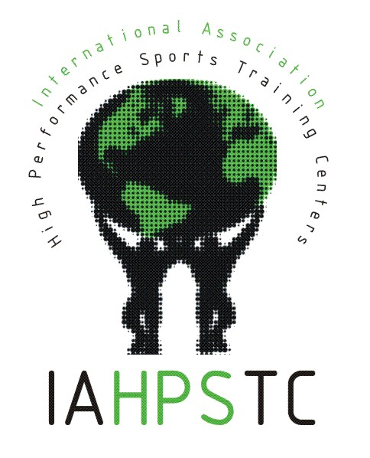
Date: < >

Dear: < >

We are please to provide you with the attached introduction to, and background information on, the International Association of High Performance Sports Training Centres (IAHPSTC).

The IAHPSTC was established as a forum and opportunity for high performance training centre personnel to better share information and collaboration for the benefit of athletes and Centres around the world. The membership criteria are:
a) To carry out its activity focused on elite sport.
b) To be officially recognized by their respective national government and/or Olympic Committee.
c) To be able to provide technical and scientific support services to high performance athletes and coaches.
d) To be willing to swap staff personnel with other high performance sports centers to exchange ideas and work methods.

Those high performance sports centers who would like to join this Association are invited to make a written request, with appropriate supporting details, to the President of the Association, at least two months before the General Assembly.

As an internationally recognized and respected high performance sport training Centre, we would welcome your involvement in this organization which is dedicated to collaboration and the sharing of experiences related to the business of high performance sport.

I will follow-up with you via email in the next few weeks. Additionally, you can contact me for more information at (<name, email, sport centre contact>) or visit our website at: www.forumelitesport.org

Sincerely,

<name>

IAHPSTC Executive Committee

