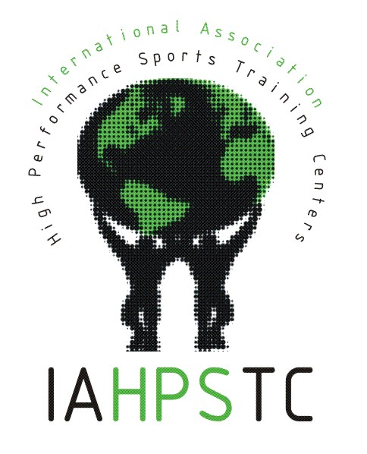
The International Association of High Performance Sports Training Centres (IAHPSTC) was conceived in Sydney, Australia in September 1999, when a group of High Performance Training Centres personnel from all over the world decided to joint efforts to share their experience. Over the past several years, the IAHPSTC has become formalized and have established a secretariat in Spain (hosted at the Centre d’Alt Rendiment de Sant Cugat del Valles).

The main purpose of this group was to explore ways to better collaborate across the world. This occurs primarily at a biennial forum of which 5 (1999 in Sydney, 2001 in Barcelona, 2003 in Loughborough, 2005 in Montreal and 2007 in Beijing) have occurred. The next forum is in Colorado Springs in 2009.

The principles of this Association are the following:
1. Respecting the Autonomy of each of the high performance sports centers:
The basic principle of the Association is considered to be the maintenance of the independence, authority and autonomy of each center as being the best guarantee of the development of high level sports in the respective countries.
2. Fostering collaboration between all the members:
Respecting the autonomy of each center, members will collaborate to generate initiatives of benefit to athletes, sport and the wider community. They will also collaborate with international organizations and associations able to assist in promoting the implementation of the principles and objectives pursued by this Association.
3. Maintaining an Ethical Approach:
Protection of the rights of high performance athletes by the IHPSTCs is essential. Specifically this should focus on their right to train and compete in a fair, ethical, healthy and safe environment.
4. Enhancing Staff Development:
IHPSTCs are committed to adding value to the training and development of their staff by providing opportunities for staff exchanges
5. Sharing Information and Knowledge:
As far as possible, the IHPSTCs will share and exchange knowledge and experiences in relation to high performance sport. They will also make information available about their center through the website forum to enable facilities and services to be promoted to athletes and coaches across the world.
6. Identifying Best Practices:
Identifying and sharing best practices is an essential element in the development of learning. The IHPSTCs will develop concepts of best practices through sharing experience and knowledge in operation and management.
7. Supporting the International Forum on Elite Sport:
The IHPSTCs will support the organization of a biennial International Forum on Elite Sport as a means of sharing and developing information and understanding of high performance sport.

For further information on the IAHPSTC, for meeting minutes and forum presentations, go to http://www.forumelitesport.org/

